SQL Syntax

🌟 Definition
# Source: AI Source: Provided by: [Data Path: Persons Table -> ID Column: 1, Name_En Column: Motasem Essam] -> From: [ChatGPT] on [6/11/2026]
SQL Syntax refers to the rules and structure used to write SQL statements correctly.
Just as English has grammar rules, SQL has syntax rules that determine how commands must be written so the database can understand them.

🎯 Purpose
# Source: AI Source: Provided by: [Data Path: Persons Table -> ID Column: 1, Name_En Column: Motasem Essam] -> From: [ChatGPT] on [6/11/2026]
SQL syntax helps:
- Communicate with a database
- Write valid SQL queries
- Retrieve and modify data
- Create and manage database objects
If the syntax is incorrect, the database returns an error.

🧠 Simple Example
# Source: AI Source: Provided by: [Data Path: Persons Table -> ID Column: 1, Name_En Column: Motasem Essam] -> From: [ChatGPT] on [6/11/2026]
SQL Statement
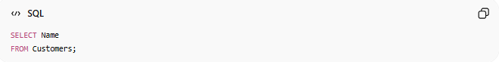
SELECT Name
FROM Customers;
This follows SQL syntax rules:
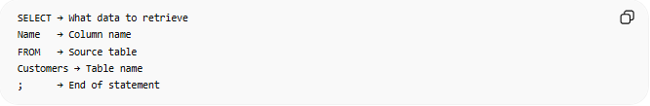
SELECT → What data to retrieve
Name → Column name
FROM → Source table
Customers → Table name
; → End of statement

📚 Basic SQL Syntax Structure
# Source: AI Source: Provided by: [Data Path: Persons Table -> ID Column: 1, Name_En Column: Motasem Essam] -> From: [ChatGPT] on [6/11/2026]
SELECT Query
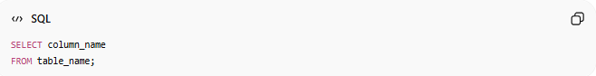
SELECT column_name
FROM table_name;
Example:
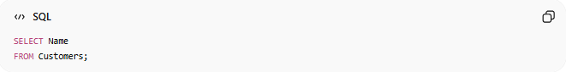
SELECT Name
FROM Customers;

🔑 Common SQL Keywords
# Source: AI Source: Provided by: [Data Path: Persons Table -> ID Column: 1, Name_En Column: Motasem Essam] -> From: [ChatGPT] on [6/11/2026]
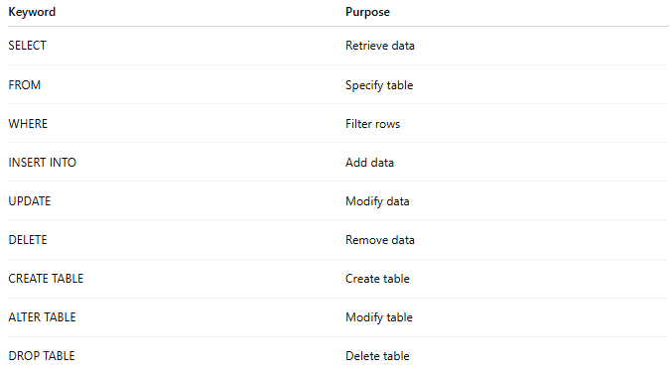
Keyword | Purpose
SELECT | Retrieve data
FROM | Specify table
WHERE | Filter rows
INSERT INTO | Add data
UPDATE | Modify data
DELETE | Remove data
CREATE TABLE | Create table
ALTER TABLE | Modify table
DROP TABLE | Delete table

📏 Basic SQL Syntax Rules
# Source: AI Source: Provided by: [Data Path: Persons Table -> ID Column: 1, Name_En Column: Motasem Essam] -> From: [ChatGPT] on [6/11/2026]
1. Keywords
SQL keywords are usually written in uppercase:
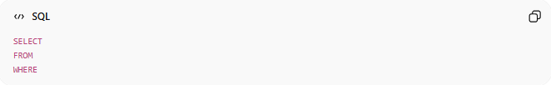
SELECT
FROM
WHERE
Although SQL is generally not case-sensitive.

2. Statement Terminator
Many SQL systems use:
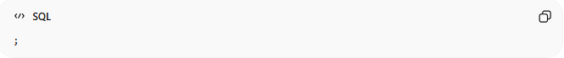
;
to mark the end of a statement.
Example:
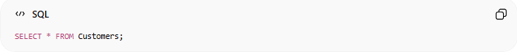
SELECT * FROM Customers;

3. Text Values Use Quotes
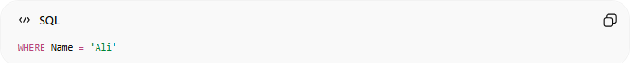
WHERE Name = 'Ali'
Text values are enclosed in single quotes.

4. Numbers Do Not Use Quotes
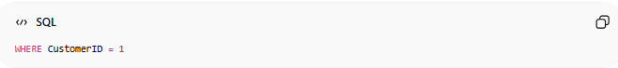
WHERE CustomerID = 1
Correct.

5. Table and Column Names
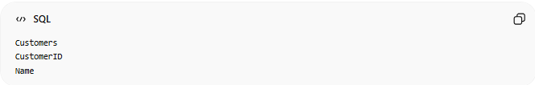
Customers
CustomerID
Name
Must match actual database objects.

⚠️ Syntax Error Example
# Source: AI Source: Provided by: [Data Path: Persons Table -> ID Column: 1, Name_En Column: Motasem Essam] -> From: [ChatGPT] on [6/11/2026]
Incorrect

SELECT FROM Customers;
Error because no column was specified.

Correct
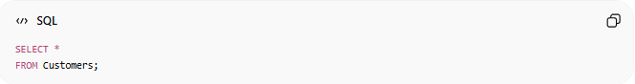
SELECT *
FROM Customers;

⚖️ Side-by-Side Comparison
# Source: AI Source: Provided by: [Data Path: Persons Table -> ID Column: 1, Name_En Column: Motasem Essam] -> From: [ChatGPT] on [6/11/2026]
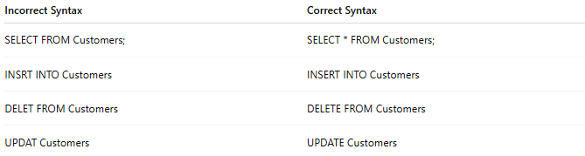
Incorrect Syntax | Correct Syntax
SELECT FROM Customers; | SELECT * FROM Customers;
INSRT INTO Customers | INSERT INTO Customers
DELET FROM Customers | DELETE FROM Customers
UPDAT Customers | UPDATE Customers

🔢 SQL Statement Pattern
# Source: AI Source: Provided by: [Data Path: Persons Table -> ID Column: 1, Name_En Column: Motasem Essam] -> From: [ChatGPT] on [6/11/2026]
Many SQL commands follow this pattern:
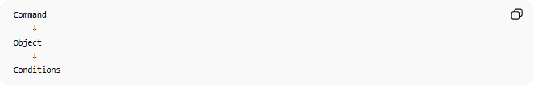
Command
↓
Object
↓
Conditions
Example:
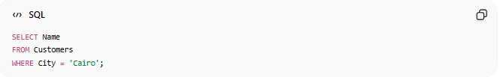
SELECT Name
FROM Customers
WHERE City = 'Cairo';

🧠 Simple Analogy
# Source: AI Source: Provided by: [Data Path: Persons Table -> ID Column: 1, Name_En Column: Motasem Essam] -> From: [ChatGPT] on [6/11/2026]
Think of SQL like English.
Correct English:
I am learning SQL.
Incorrect English:
Learning am SQL I.
The words exist, but the grammar is wrong.
Similarly:
Correct SQL:
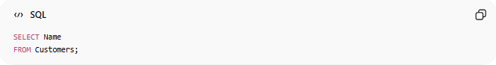
SELECT Name
FROM Customers;
Incorrect SQL:
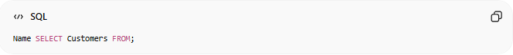
Name SELECT Customers FROM;
The database cannot understand it.

🧭 Summary
# Source: AI Source: Provided by: [Data Path: Persons Table -> ID Column: 1, Name_En Column: Motasem Essam] -> From: [ChatGPT] on [6/11/2026]
SQL Syntax is the set of rules and structure used to write valid SQL statements. It defines how commands such as SELECT, INSERT, UPDATE, DELETE, and CREATE TABLE must be written so that a database can understand and execute them correctly. Following proper SQL syntax is essential for querying and managing data successfully.

